**A**

**Project Report On**

**“BookMyShow”**

**Submitted in the fulfillment of the requirement of the certification of**

**“Manual Testing”**

**Submitted by**

**Shreyash Dahikar**



## Impetus Consultrainers

2022-23

Signature of guide



## Impetus Consultrainers

**CERTIFICATE**

This is to certify that **Shreyash Dahikar** have satisfactorily carried out theirs

Project work entitled.

**“BookMyShow”**

It is also certify that this is their own work completed during (3.5) months. The work done is satisfactory and is presented as per the specification.

**PROJECT GUIDE HEAD OF DEPARTMENT**

**DATE:**

**PLACE:**

**ACKNOWLEDGEMENT**

I gratefully acknowledge the assistance provided to me by the following authorities in the completion of my project titled as **“BookMyShow”**.

I take this opportunity to thank all those who have been directly or indirectly related to my project. I specially thank my project guide **Miss. Bhavna**

**Chawda** for her timely assistance and for sharing her experience and knowledge, and above all for the invaluable guidance that keeps me going and inspires me to perform better.

I am highly obliged to thanks **Mrs. Seema Shelar** for her effort and encouragement that boosted my moral and given me gain experience. I also thank her efforts, which she devoted towards me.

We take this opportunity to sincerely thank all our professors from the

“**Impetus Consultrainers”**. I acknowledge the many authors whose work has been quoted in this project.

Last but not the least, I would like to thank my family members, all friends &well-wishers who always support me, wish the best for me & helped to complete the project successfully.

Thanking You,

Shreyash Dahikar

**Index**

|  |  |  |
| --- | --- | --- |
| **Sr. No.** | **Title** | **Page No.** |
| 1 | Introduction | 5 |
| 2 | Scope and Project | 6 |
| 3 | Roles and Responsibilities | 7 |
| 4 | System Requirements | 8-17 |
| 5 | Test Cases | 18-25 |
| 6 | Defects with Screenshots | 26-30 |
| 7 | Defects log | 31 |
| 8 | Requirements Traceability Matrix ( R.T.M ) | 32-39 |

**INTRODUCTION**

BookMyShow is India’s biggest online movie and events ticketing brand.

The website caters to ticket sales for movies, plays, concerts and sporting

events vie online platform. Launched in 2007, it is headquartered in

Mumbai, Maharashtra. It additionally has offices in New Delhi,

Bangalore, Hyderabad, Chennai and Kolkata.

BookMyShow was founded by Ashish Hemrajani, Parikshit Dar and Rajesh Balpande,

all three alumni of Sydenham Institute of Management, Mumbai University.

They had been working for J.W. Thompson, SPAR and Chatterjee Soros Group,

Respectively. In 2007 they officially came up with the BookMyShow website.

The major purpose of this start-up was to bring the concept of online movie ticketing

to India. And soon as it expanded, it started offering online ticketing solutions for

Theatres, events, concerts and sports.

During its initial years, BookMyShow had a small team managing all the operations.

It now employs more than 400 people. BookMyShow’s online ticketing platform

is considered to be the main reason behind its success.

BookMyShow is an online ticketing facility like Movietickets.com, Explara and

Ticketmaster.com. BookMyShow took the primary services provided by these

two websites and consolidated it into one website for movies, plays, events

and sports tickets. Apart from being an online ticketing portal, BookMyShow

offers information about upcoming movies and events, show timings, venue

details and artist bios.

**SCOPE OF PROJECT**

Objective

* In this project we have test all the module wise sections with

requirement and screenshots.

* We have written all positive and negative test cases with respective

to the requirements.

* We have done end to end testing and found functional and non-

functional defects which is divided in severity types.

* We also included Requirement Traceability Matrix. The overall

Purpose of the testing is to ensure that <https://www.bookmyshow.com>

meets all of its requirements.

* It describes test plan and strategy. The approach described in this document

provides the framework for all testing related to this website.

**ROLES & RESPOMSIBILITIES**

* Selection of project with proper understanding and study of the

application.

* Makes Software Requirements Specification by own self.
* Prepare Test cases as per the requirements.
* Prepare Requirements Traceability Matrix.
* Find the defects with screenshots.

**Requirements**

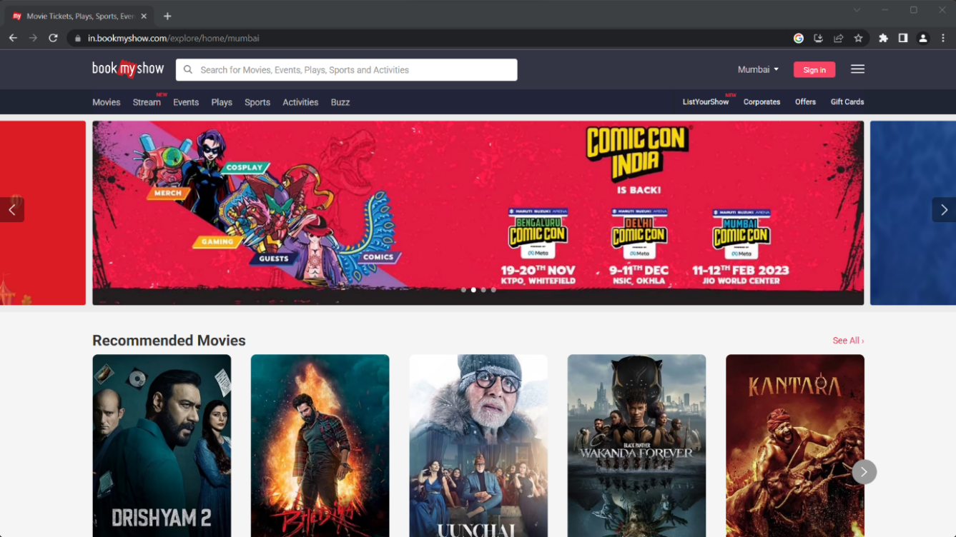

**1.Requirements for homepage :**

R1 : Website should be run on all popular web browser.

R2 : Containing search too bar, location, login and notification option at upper side of page.

R3 : If user click on any page which display on home page, then page open with new tab.

R4 : Top menu bar should contains following list :

* Movies
* New Stream
* Events
* Plays
* Sports
* Activities
* Buzz
* List your show
* Corporates
* Offers
* Gift Cards

R5 : When user move cursor on menu bar, detail list of all related movies should be display.

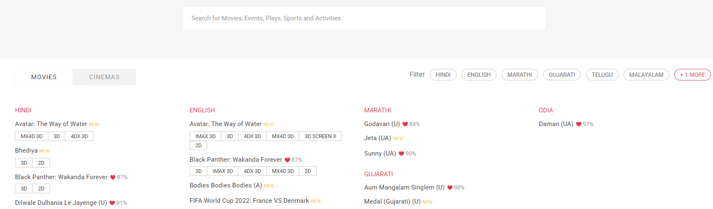

**2.Requirement for search button :**

R6 : Clicking search button than show the all movies and cinemas.

R7 : Searching Black Panther Wakanda Forever movie show the

screen.

R8 : Search movie theatre near by location.

R9 : show the all details for movies ex. Language, screening, cast and crew etc.

R10 : Search the theatre and show the witch show is available and show the timing

and how many seat available.

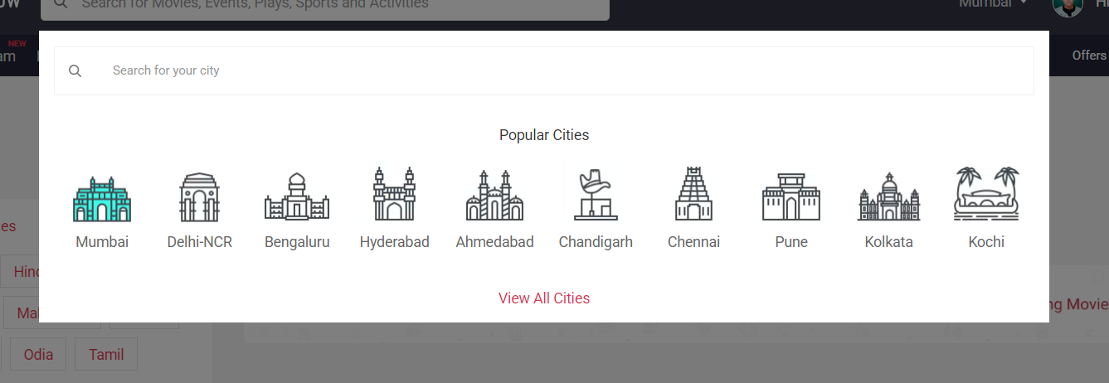

**3. Requirement for Locations.**

R11 : Select search for popular cities.

R12 : Select location should contain all popular cities.

R13 : After clicking View All Cities then all city name should be A to Z format.

R14 : City name should be first letter is capital.

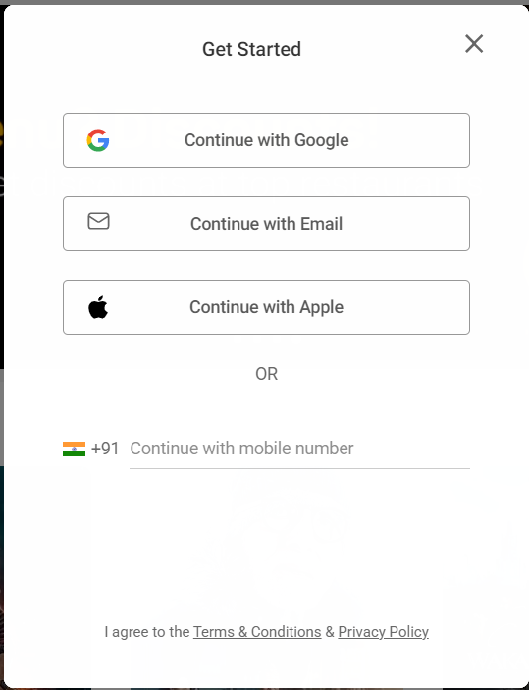

**4. Requirements for Sign in page.**

R15 : After clicking sign in page should be show in display.

R16 : if user is new to account then there should be sign in button to create new account.

R17 : After clicking sign in, mobile number option for registration should display with

Continue button.

R18 : OTP should be in length 6 digit and matched with message.

R19 : It cannot be empty.

R20 : Signup should be successful only with valid OTP code.

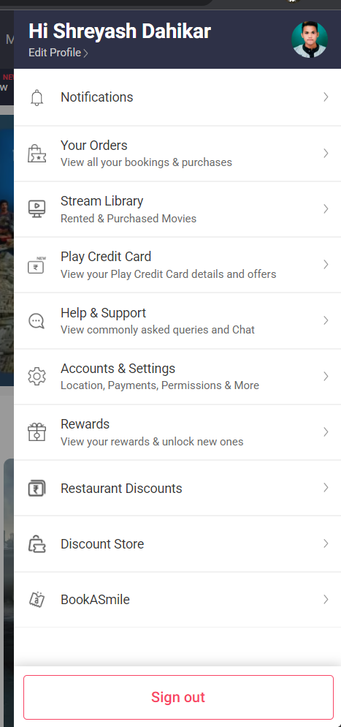

**5.1 Requirements for Notifications page.**

R21 : Open notification page show the all notifications.

**5.2 Requirements for Your orders.**

R22 : After clicking order button show the Recent booking,

Pre-booking and Add Ons.

R23 : Open the order page view all your booking and purchases.

**5.3 Requirements for Stream Library.**

R24 : Open Stream Library view all option ex. Rented, Purchased

and Downloaded movies.

R25 : After opening Stream library show movie then clicking

movie they show us Rent or Buy movie.

**5.4 Requirements for Play Credit Card.**

R26 : Open new page than show two option My Play Card and Offer & Benefits.

R27 : Open Credit Card option they show Application option then

show gift Vouchers.

R28 : Clicking apply credit card option they show all apply proceed.

1) Verify PAN Card number

2) Date of Birth

3) Gender (Male, Female, Other)

4) Email Address

5) Mobile number.

R29 : After clicking Enter Address they show new page

1. Area Pin code
2. Address Line 1
3. Address Line 2(optional)
4. Town/ City
5. State.

R30 : After Clicking Credit card apply they show you credit card

Limit how to you use.

R31: Then go to next Step KYC option.

R32 : After KYC completed then they show your proceed are completed.

R33 : After clicking Offers & Benefits they show all gift vouchers you buy.

**5.5 Requirements for Help & Support.**

R34 : After clicking Help & Support they show all support lines.

R35 : Then clicking help page they show chat option.

**5.6 Requirements for Accounts & Settings.**

R36 : After clicking Account & Settings they show two option

Saved Payment modes and Saved Devices.

R37 : After clicking Payment modes they many option

1. Credit/Debit Cards option.
2. Net Banking option.
3. Gift Vouchers option.
4. Other Wallets option.
5. Redeem Points / Other partners
6. UPI option.

R38 : After clicking Credit/Debit cards option they show card details

Pages.

R39 : Then show the card details Enter the card number should be numerical.

R40 : Then fill the name on the card details.

R41 : After Card name should be first letter are Capital.

R42 : Then fill the Month and Year should be numerical.

R43 : Then fill the Name of the card(Ex family card).

R44 : Select the Verify and continue button and go to next page.

R45 : After Enter CVV number shown at the back of your credit/debit card.

R46 : Then Enter CVV number and click the continue button.

R47 : After clicking Payment mood they send OTP code in your mobile number.

R48 : After clicking Net banking they show all bank and choice your bank and

Click and add.

R49 : You can also Remove your choice bank.

R50 : After clicking Gift Vouchers Enter the gift vouchers code and add.

R51 : Gift Vouchers Code should be numeric.

R52 : You choice also other wallets payments option.

R53 : You also choice Redeem Points use to payments mode.

R54 : After clicking UPI mode add your valid VPA Address/Mobile number.

R55 : UPI id should be alphanumerical.

R56 : UPI id use special character. (ex @)

R57 : You can also Remove your UPI id.

R58 : After clicking Saved Devices they show how system you login this website.

R59 : You can also remove your Devices.

**5.7 Requirements for Rewards.**

R60 : Click Rewards page they show how to unlock Reward.

R61 : Book some movie and event of your choice then Complete the

Payment & click on the reward banner on the booking confirmation page.

**5.8 Requirements for Restaurant Discounts.**

R62 : Then you want some Discount then you buy some movies ticket or event ticket.

**5.9 Requirements for Discount store.**

R62 : After you buy some movie ticket then they give some Discount

and you store this page.

**5.10 Requirements for BookASmile.**

R63 : After open new page they show Donate option you choice you want donate any amount.

R64 : After clicking donate button then they show payment mode.

**6 Requirements for Sign out.**

R65 : After clicking Sign out button then they show Home page.

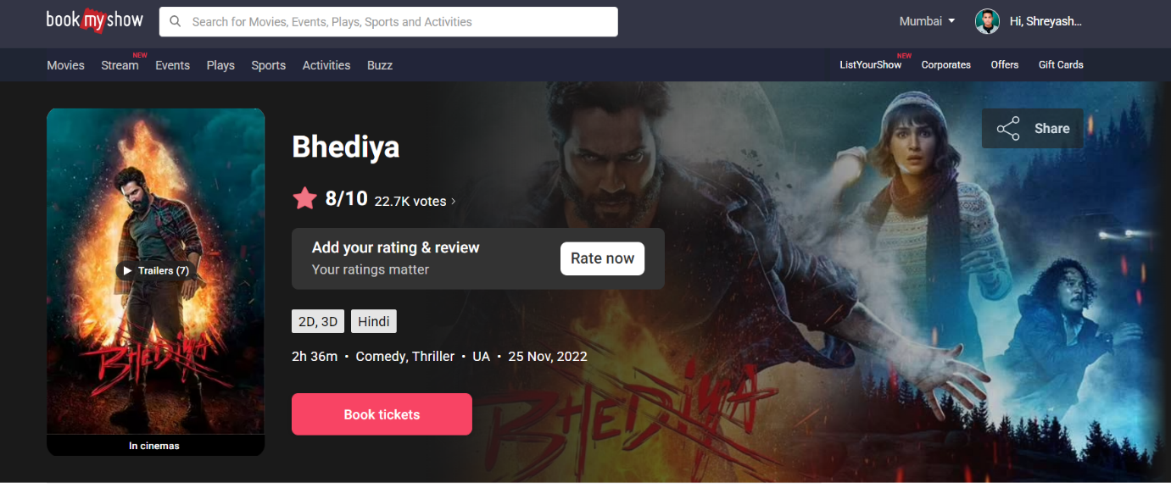

**7 Requirements for Booking Tickets.**

R66 : Click book ticket than they show movie rating, language,2D/3D, timing

and release date.

R67 : After clicking book ticket than they show select language and 2D/3D option.

R68 : After select language and 2D option than they show Theatre location and timing.

R69 : After Select theatre and time than they show how many seat are available and show price also.

R70 : Then select seat go to the payment mode option.

R71 : Select payment mode go to the many payment option are available.

Ex. 1) Quik Pay

2) Credit/Debit card

3) Net banking

4) Mobile wallets

5) Gift vouchers

6) UPI

7) Redeem points

R72 : After choice UPI option then book ticket .

R73 : Then book ticket sent the massage your Email or mobile number.

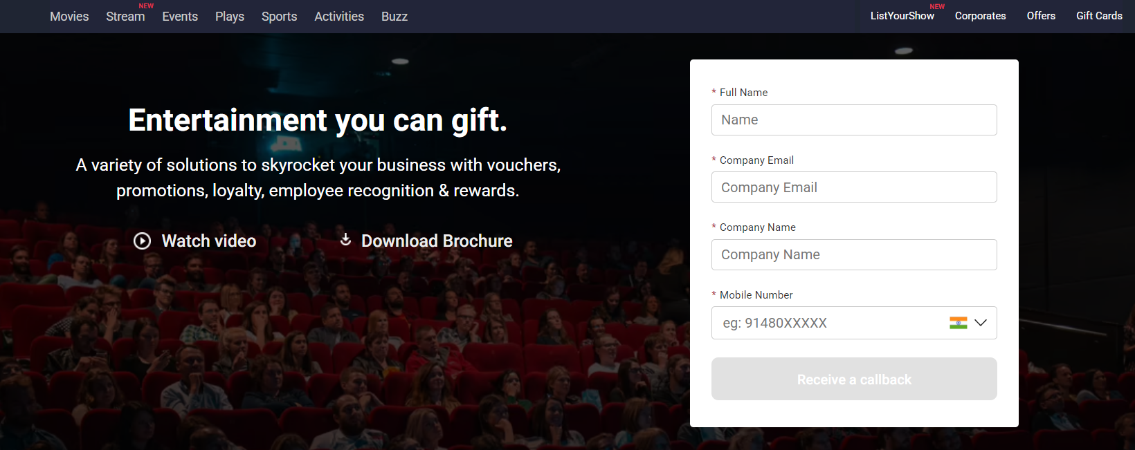

**8 Requirements of Corporates page.**

R74 : Click on Corporates page then open Details page.

R75 : After enter fill Full Name should be 1st Letter will be Capital.

R76 : Then Enter your Company Email id.

R77 : After Enter your Company Name.

R78 : After Enter Mobile number should Numerical.

R79 : After Click Receive & Call back Button they show new page.

R80 : After Click Receive & Call back button they show your request we received.

**TEST CASES**

|  |  |  |  |  |  |  |  |
| --- | --- | --- | --- | --- | --- | --- | --- |
| **Req ID** | **Test Case Id** | **Pre-Condition** | **Test Case Description** | **Steps** | **Input** | **Expected O/P** | **Results** |
|  | TC01 | Google chrome must be available | To Verify the running of BookMyShow on Google chrome Browser. | 1. Click on Google chrome Browser.  2. Enter [WWW.BookMyShow.com](http://WWW.BookMyShow.com) in URL OR Search option.  3. Press Enter Button. | <http://www.bookmyshow.com/> | BookMyShow should be run on Google chrome. | Pass |
|  | TC02 | Mozilla Firefox must be Available | To Verify the running of BookMyShow on Mozilla Firefox Browser. | 1. Click on Mozilla Firefox Browser.  2. Enter [WWW.BookMyShow.com](http://WWW.BookMyShow.com) in URL or Search option.  3. Press Enter Button. | <http://www.bookmyshow.com/> | BookMyShow should be run on Mozilla Firefox. | Pass |
| R01 | TC03 | Internet Explorer must be Available. | To Verify the running of BookMyShow on Internet Explorer Browser. | 1. Click on Internet Explorer Browser.  2. Enter [WWW.BookMyShow.com](http://WWW.BookMyShow.com) in URL or search option.  3. Press Enter Button. | <http://www.bookmyshow.com/> | BookMyShow should be run on Internet Explorer Browser. | Fail |
|  | TC04 | Opera Browser must be available. | To Verify the running of BookMyShow on Opera Browser. | 1. Click on Opera Browser.  2. Enter [WWW.BookMyShow.com](http://WWW.BookMyShow.com) in URL or search option.  3. Press Enter Button. | <http://www.bookmyshow.com/> | BookMyShow should be run on Opera Browser. | Pass |
|  | TC05 | UC Browser must be available. | To Verify the running of BookMyShow on UC Browser. | 1. Click on UC Browser.  2. Enter [WWW.BookMyShow.com](http://WWW.BookMyShow.com) in URL or search option.  3. Press Enter Button. | <http://www.bookmyshow.com/> | BookMyShow should be run on UC Browser. | Pass |

|  |  |  |  |  |  |  |  |
| --- | --- | --- | --- | --- | --- | --- | --- |
| R02 | TC06 | Check sign in | Check Sign in page | 1. Click on sign in button.  2. Enter Sign in page.  3. Press Enter Button. |  | Login page will be displayed. | Pass |
| R03 | TC07 | Check login with Valid data | Enter Valid Mobile Number click login | 1. Click on login page button.  2. Enter your Mobile number.  3. Press Enter Button. | Mobile Number.********** | Home page will be displayed. | Pass |
|  | TC08 | Check login with Valid data | Enter Invalid Mobile Number click login | 1. Click on login page button.  2. Enter your Mobile Number.  3. Press Enter Button. | Mobile Number.123.555.753 | “Please enter you’re the valid mobile number” message will be displayed. | Pass |
|  | TC09 | Check login with Valid data | Enter Valid Email Id | 1. Click on login page button.  2. Enter your Email id.  3. Press Enter Button. | Email id. shreyashdahikar@gmail.com | Home page will be displayed. | Pass |
|  | TC10 | Check login with Valid data | Enter Invalid  Email id | 1. Click on login page button.  2. Enter your Email id.  3. Press Enter Button. | Email id. ****+@gamil.com | “Invalid email id” message should be displayed. | Fail |
|  | TC11 | Check login with Valid data | Enter already registered number in signup | 1. Click on login page button.  2. Enter your Mobile Number.  3. Press Enter Button | Mobile Number.********** | “This Mobile Number is already registered” message should be displayed. | Fail |
|  | TC12 | Check login with Valid data | Enter Invalid OPT code | 1. Click on login page button.  2. Enter OTP code.  3. Press Enter Button. | OTP.111111 | “We couldn’t verify your code. Please try again” message will be displayed. | Pass |
|  | TC13 | Check login with Valid data | Click Terms and Conditions | 1. Click on login page button.  2. Click Terms and conditions page.  3. Press Enter Button. |  | Terms and Conditions page will be displayed. | Pass |

|  |  |  |  |  |  |  |  |
| --- | --- | --- | --- | --- | --- | --- | --- |
| R04 | TC14 | Check Sign up | Click Sign up page Enter the valid mobile number | 1. Click on Sign up page button.  2. Click Sign up page.  3 Press Enter Button. | Mobile Number.********** | Verify your Mobile number page will be displayed | Pass |
|  | TC15 | Check Sign up | Click Sign up page Enter the Valid mobile number | 1. Click on Sign up page Button.  2. Click Sign up page.  3. Press Enter Button. | Mobile Number.123.555.753 | Sign Up Icon will be disabled | Pass |
| R05 | TC16 | Check Settings | Click Settings | 1. Click on Setting page button.  2. Click Setting page.  3. Press Enter Button. |  | Check User information page will be displayed | Pass |
|  | TC17 | Check Settings | Leave First Name Click Update | 1. Click on Setting page button.  2. Click First Name update button.  3. Press Enter Button. |  | “Please enter your First name” message should be displayed. | Pass |
|  | TC18 | Check Settings | Leave last name Click Update | 1. Click on Setting page button.  2. Click last name update Button.  3. Press Enter Button. |  | “Please enter your last name” message should be displayed. | Pass |
|  | TC19 | Check Settings | Select valid Date of Birth | 1. Click on Setting page button.  2. Enter Date of Birth page.  3. Press Enter Button. | BOD : 30/02/1998 | “Select the valid date” message should be displayed. | Fail |
|  | TC20 | Check Settings | Leave Mobile number blank Click Update | 1. Click on Setting page button.  2. Enter Mobile Number Blank Update page button.  3. Press Enter Button. |  | “Please enter your mobile number” message should be displayed. | Pass |
|  | TC21 | Check Settings | Fill all Valid details Click Update | 1. Click on Setting page button.  2. Enter Fill all Valid Details update page button.  3. Press Enter Button. |  | “Profile Updated Successfully” message should be displayed. | Pass |
| R06 | TC22 | Check Notification | Click Notification page | 1. Click on Notification page button.  2. Enter Notification page button.  3. Press Enter Button. |  | Notification page will be displayed. | Pass |
| R07 | TC23 | Check Booking History | Click Booking History page | 1. Click on Booking History page button.  2. Enter Booking History page button.  3. Press Enter Button. |  | Recent Booked movies , event will be displayed. | Pass |
| R08 | TC24 | Check Quick Pay | Click Quick pay page | 1. Click on Quick pay page.  2. Enter Quick pay page.  3. Press Enter Button. |  | Payment Option will be displayed. | Pass |
| R09 | TC25 | Check Support | Click Support page | 1. Click on Support page.  2. Enter Support page.  3. Press Enter Button. |  | Support Center page will be displayed. | Pass |
|  | TC26 | Check Movies | Click movie page | 1. Click on movies page.  2. Enter the movie page.  3. Press Enter Button. |  | Movie homepage will be displayed | Pass |
|  | TC27 | Select some particular Language | Click some particular Language page | 1. Click on Some particular Language page.  2. Enter Particular Language page.  3. Press Enter Button. | Malayalam | Selected Language movies will be displayed. | Pass |
|  | TC28 | Select two or more movie language | Click two or more movie language page | 1. Click on two or more movie language page.  2. Enter two or more movie language page.  3. Press Enter Button. | English  Marathi | All Box should be selected. | pass |
| R10 | TC29 | Click on Movies Select Coming soon Click the like icon of any movies. | Select movie coming soon and like icon of any movies page | 1. Click coming soon movies and like icon of any movies page.  2. Enter coming soon movies.  3. Press Enter Button. |  | Like will be recorded. | Fail. |
|  | TC30 | Click any movie Click the BOOK TICKETS icon Accept the terms and condition Select the seat position then click pay Enter the invalid email id in share your contact details text box | Click any movie and Book Tickets icon Accept terms and condition then pay Enter the Invalid email id on share your contact details text page. | 1. Click any movie and Book tickets icon accept the terms and condition select seat position then click pay Enter the invalid email id page.  2. Enter movie and book ticket and accept terms and condition then click pay Enter Invalid email id.  3. Press Enter button. | Email address: [***+@gmail.com](mailto:***+@gmail.com) | It should not accept the invalid email address | Fail |
|  | TC31 | Check Coming Soon | Click Coming Soon page | 1. Click on Coming Soon page.  2. Enter Coming soon page.  3. Press Enter Button. |  | User will be able to access that page. | Pass |
| R11 | TC32 | Check Exclusive | Click Exclusive page | 1. Click on Exclusive page.  2. Enter Exclusive page.  3. Press Enter Button. |  | User will be able to access that page. | Pass |
| R12 | TC33 | Check Language | Click Language page | 1. Click on Language page.  2. Enter Language page.  3. Press Enter Button. |  | All the module should be changed to that language. | Pass |
|  | TC34 | Check City | Click City page Type Invalid city name | 1. Click on City page.  2. Enter City page.  3. Press Enter Button. |  | “No Matching Result” Message will be displayed | Pass |
| R13 | TC35 | Check City | Click City Type valid city name | 1. Click on City name.  2. Enter City name.  3. Press Enter Button |  | It will be selected. | Pass |
| R14 | TC36 | Check Events | Click Events page | 1. Click on Event page.  2. Enter Event page.  3. Press Enter Button. |  | The Event home page will be displayed | Pass |
|  | TC37 | Check Events | Click price Range Select Range page | 1. Click price range select range page.  2. Enter Price range and select range page.  3. Press Enter Button. | 0 - 1000 | Only below 1000 range event will be displayed | Pass |
|  | TC38 | Check Events | Click date select Today date page | 1. Click on date page.  2. Enter the select Today date page.  3. Press Enter Button. | Today | Only Today events will be displayed. | Pass |
|  | TC39 | Check Comedy Show | Click Comedy Show page | 1. Click on Comedy Show page.  2. Enter Comedy Show page.  3. Press Enter Button. |  | Comedy show home page will be displayed. | Pass |
| R15 | TC40 | Check Comedy Show | Click Select any one of the categories page | 1. Click on Select any one of the categories page.  2. Enter Select any one of the categories page.  3. Press Enter Button. | Stand Up Comedy Improv Comedy | Selected Categories will be displayed. | Pass |
|  | TC41 | Check Sports | Click Sports page | 1. Click on Sports page.  2. Enter Sports page.  3. Press Enter Button. |  | Sports homepage will be displayed. | Pass |
| R16 | TC42 | Check Sports | Click Select any events click Book | 1. Click on Select any events click book page.  2. Enter select any events click book page.  3. Press Enter Button. |  | Categories page will be displayed | Pass |
|  | TC43 | Check International | Click International page | 1. Click on International page.  2. Enter International page.  3. Press Enter Button. |  | User will be able to access International page. | Pass |
| R17 | TC44 | Check International | Click International page | 1. Click on International page.  2. Enter International page.  3. Press Enter Button. |  | It should be open in a new tab. | Pass |
|  | TC45 | Check Activities | Click select Activities | 1. Click on Activities page.  2. Enter Activities page.  3. Press Enter Button. |  | User will be able to access activities page. | Pass |
| R18 | TC46 | Check Activities | Click Select Activities click any events click Book | 1. Click on Activities page click any events click Book page.  2. Enter Activities page click any events click Book page.  3. Press Enter Button. |  | User will be able to book. | Pass |
|  | TC47 | Check Corporates | Click Corporates page | 1. Click on Corporates page.  2. Enter Corporates page.  3. Press Enter Button. |  | Corporate homepage will be displayed. | Pass |
|  | TC48 | Check Corporates | Click Corporates Type Number in First Name | 1. Click on Corporates Type Number in First Name page.  2. Enter Corporates Type Number in First Name page.  3. Press Enter Button. | First Name: 9654782 | “First Name should only be number” message should be displayed. | Fail |
| R19 | TC49 | Check Corporates | Click Corporates Type Character in Mobile Number | 1. Click on Corporates Type character in Mobile Number page.  2. Enter Corporates Type Character in Mobile Number page.  3. Press Enter Button. | Mobile Number: bafeghcsrg | “Invalid mobile number” message should be displayed. | Fail |
|  | TC50 | Check Corporates | Click Corporates Leave Email id click submit | 1. Click on Corporates leave email id click submit page.  2. Enter Corporates leave email id click submit page.  3. Press Enter Button. |  | “Emails appears to be incorrect or is empty” message should be displayed. | Pass |
| R20 | TC51 | Check Offers | Click Offers | 1. Click on Offers page.  2. Enter Offers page.  3. Press Enter Button. |  | Offers Homepage will be displayed | Pass |
|  | TC52 | Check Offers | Click Offers Select Credit cards page | 1. Click on offer page select Credit cards page.  2. Enter Credit cards page.  3. Press Enter Button. |  | User Can able to see all credit card offers. | Pass |
|  | TC53 | Check Offers | Click Offers Select Debit cards page | 1. Click on Offer page Select Debit Cards page.  2. Enter Offer page select Debit cards page.  3. Press Enter Button. |  | User Can able to see all debit card offers. | Pass |
|  | TC54 | Check Offers | Click Offers Type offers Search page | 1. Click on Offer page Type offers search page.  2. Enter Offer page Type offers search page.  3. Press Enter Button. | SBI | All SBI bank offers will be displayed. | Pass |
|  | TC55 | Check Gift Cards | Click Gift cards page | 1. Click on Gift cards page.  2. Enter Gift cards page.  3. Press Enter Button. |  | Gift cards homepage will be displayed. | Pass |
| R21 | TC56 | Check Gift Cards | Click Gift cards Select any gift cards Type Character in From page | 1. Click on Gift cards select any gift cards Type Character in from page.  2. Enter Gift cards select any gift cards type Character in from page.  3. Press Enter Button. | From : shreyash | It accept character field | Pass |
|  | TC57 | Check Gift Cards | Click Gift cards Select any gift cards Type Number in MOBILE NUMBER page | 1. Click on Gift cards select any gift cards Type Number in Mobile Number page.  2. Enter Gift card Type Number in Mobile Number page.  3. Press Enter Button. | MOBILE NUMBER: 9637242888 | It accept number field. | Pass |
| R22 | TC58 | Check Sign Out | Click Sign out page | 1. Click Sign out page.  2. Enter Sign out page.  3. Press Enter Button. |  | User can able to sign out. | Pass |

**Defects With Screenshots.**

**1 Defect of Sign in Email Id.**

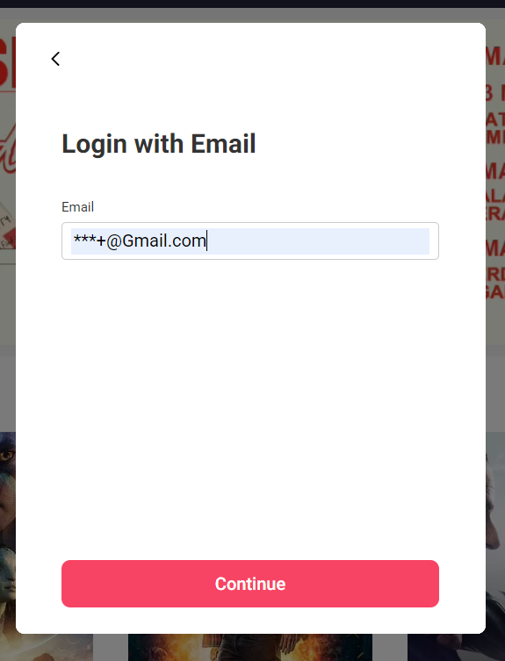

Defects 1. This Email id page will be Accept the Invalid Email Id and Sending OPT Code.

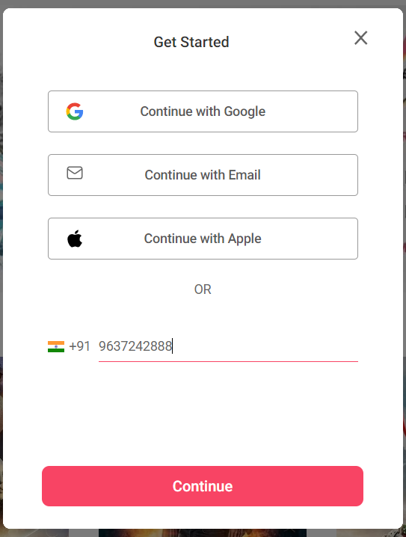

Defect 2. This Mobile Number already Registered this page but It Accept Same Mobile number.

**2 Defects of Setting Birth of date page.**

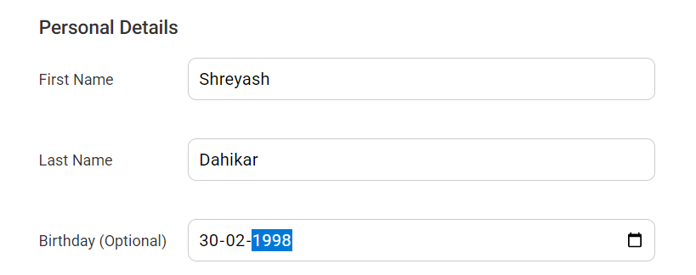

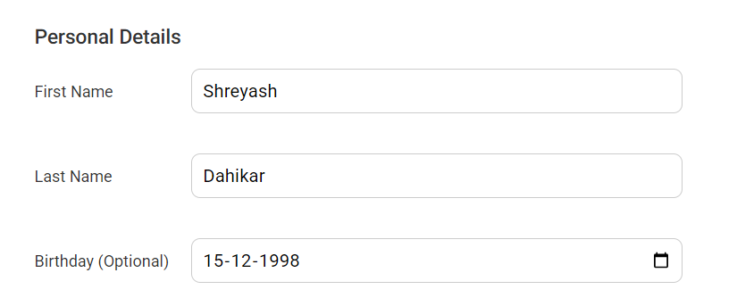

Defect 3. While selecting Birth of date number It Doesn’t show message.

**3 Defects of Movie page.**

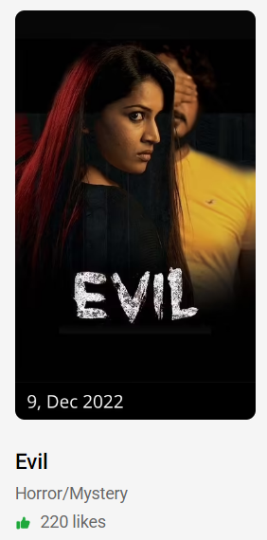

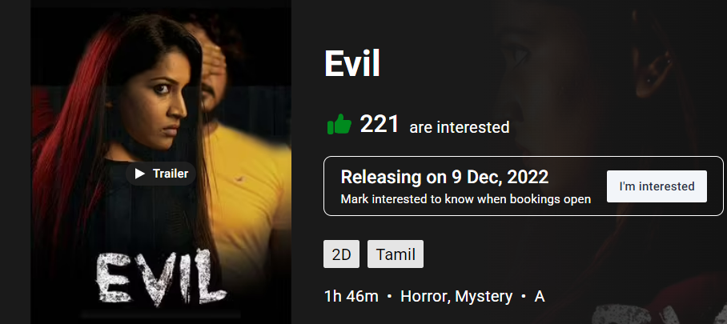

Defect 4. While refreshing the page it’s changed.



Defect 5. It Accept the invalid Email Id.

**4 Defects of Corporates page.**

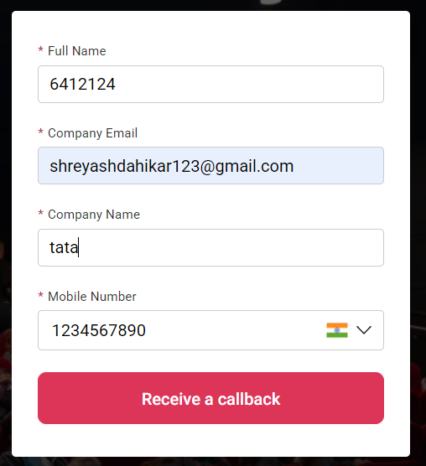

Defect 5. It Accept the number in character field.

Defect 6. It Accept the character in number field.

**DEFECT LOG**

|  |  |  |  |  |
| --- | --- | --- | --- | --- |
| DEFECT LOG | SUMMERY | URL | TYPE | SEVERITY |
| 01 | Not compatible with Internet Explorer. | <http://www.bookmyshow.com/> | Non-Functional | Medium |
| 02 | Accept Invalid Email ID  Ex- ***+@Gmail.com | <http://www.bookmyshow.com/> | Functional | Medium |
| 03 | Accept Invalid BOD  Ex- 30-02-1998 | <http://www.bookmyshow.com/> | Non-Functional | Low |

**REQUIREMENT TRACEABILITY MATRIX ( R.T.M )**

**BROWSER 1 :**

|  |  |  |  |  |  |
| --- | --- | --- | --- | --- | --- |
|  | TC01 | TC02 | TC03 | TCO4 | TC05 |
| R01 |  |  |  |  |  |
| R02 |  |  |  |  |  |
| R03 |  |  |  |  |  |
| R04 |  |  |  |  |  |
| R05 |  |  |  |  |  |

**SIGN IN 2 :**

**LOGIN 3 :**

|  |  |  |  |  |  |  |  |  |
| --- | --- | --- | --- | --- | --- | --- | --- | --- |
|  | TC06 | TC07 | TC08 | TC09 | TC10 | TC11 | TC12 | TC13 |
| RO1 |  |  |  |  |  |  |  |  |
| R01 |  |  |  |  |  |  |  |  |
| R02 |  |  |  |  |  |  |  |  |
| R03 |  |  |  |  |  |  |  |  |
| R04 |  |  |  |  |  |  |  |  |
| R05 |  |  |  |  |  |  |  |  |
| R06 |  |  |  |  |  |  |  |  |
| R07 |  |  |  |  |  |  |  |  |

**SIGN UP 4:**

**SETTINGS 5:**

|  |  |  |  |  |  |  |  |  |
| --- | --- | --- | --- | --- | --- | --- | --- | --- |
|  | TC14 | TC15 | TC16 | TC17 | TC18 | TC19 | TC20 | TC21 |
| RO1 |  |  |  |  |  |  |  |  |
| R02 |  |  |  |  |  |  |  |  |
| R01 |  |  |  |  |  |  |  |  |
| R02 |  |  |  |  |  |  |  |  |
| R03 |  |  |  |  |  |  |  |  |
| R04 |  |  |  |  |  |  |  |  |
| R05 |  |  |  |  |  |  |  |  |
| R06 |  |  |  |  |  |  |  |  |

**NOTIFICATION 6:**

**BOOKING HISTORY 7:**

**QUICK PAY 8:**

**SUPPORT 9:**

**MOVIES 10:**

|  |  |  |  |  |  |  |  |  |  |  |
| --- | --- | --- | --- | --- | --- | --- | --- | --- | --- | --- |
|  | TC22 | TC23 | TC24 | TC25 | TC26 | TC27 | TC28 | TC29 | TC30 | TC31 |
| R01 |  |  |  |  |  |  |  |  |  |  |
| R01 |  |  |  |  |  |  |  |  |  |  |
| R01 |  |  |  |  |  |  |  |  |  |  |
| R01 |  |  |  |  |  |  |  |  |  |  |
| R02 |  |  |  |  |  |  |  |  |  |  |
| R03 |  |  |  |  |  |  |  |  |  |  |
| R04 |  |  |  |  |  |  |  |  |  |  |
| R05 |  |  |  |  |  |  |  |  |  |  |
| R06 |  |  |  |  |  |  |  |  |  |  |
| R07 |  |  |  |  |  |  |  |  |  |  |

**EXCLUSIVE 11:**

**LANGUAGES 12:**

**CITY 13:**

**EVENTS 14:**

|  |  |  |  |  |  |  |  |
| --- | --- | --- | --- | --- | --- | --- | --- |
|  | TC32 | TC33 | TC34 | TC35 | TC36 | TC37 | TC38 |
| R01 |  |  |  |  |  |  |  |
| R01 |  |  |  |  |  |  |  |
| R01 |  |  |  |  |  |  |  |
| R02 |  |  |  |  |  |  |  |
| R01 |  |  |  |  |  |  |  |
| R02 |  |  |  |  |  |  |  |
| R03 |  |  |  |  |  |  |  |

**COMENDY SHOW 15:**

**SPORTS 16:**

**INTERNATIONAL 17:**

**ACTIVITIES 18:**

|  |  |  |  |  |  |  |  |  |
| --- | --- | --- | --- | --- | --- | --- | --- | --- |
|  | TC39 | TC40 | TC41 | TC42 | TC43 | TC44 | TC45 | TC46 |
| R01 |  |  |  |  |  |  |  |  |
| R02 |  |  |  |  |  |  |  |  |
| R01 |  |  |  |  |  |  |  |  |
| R02 |  |  |  |  |  |  |  |  |
| R01 |  |  |  |  |  |  |  |  |
| R02 |  |  |  |  |  |  |  |  |
| R01 |  |  |  |  |  |  |  |  |
| R02 |  |  |  |  |  |  |  |  |

**CORPORATES 19:**

**OFFERS 20:**

|  |  |  |  |  |  |  |  |  |
| --- | --- | --- | --- | --- | --- | --- | --- | --- |
|  | TC47 | TC48 | TC49 | TC50 | TC51 | TC52 | TC53 | TC54 |
| R01 |  |  |  |  |  |  |  |  |
| R02 |  |  |  |  |  |  |  |  |
| R03 |  |  |  |  |  |  |  |  |
| R04 |  |  |  |  |  |  |  |  |
| R01 |  |  |  |  |  |  |  |  |
| R02 |  |  |  |  |  |  |  |  |
| R03 |  |  |  |  |  |  |  |  |
| R04 |  |  |  |  |  |  |  |  |

**GIFT CARDS 21:**

**SIGN OUT 22:**

|  |  |  |  |  |
| --- | --- | --- | --- | --- |
|  | TC55 | TC56 | TC57 | TC58 |
| R01 |  |  |  |  |
| R02 |  |  |  |  |
| R03 |  |  |  |  |
| R01 |  |  |  |  |